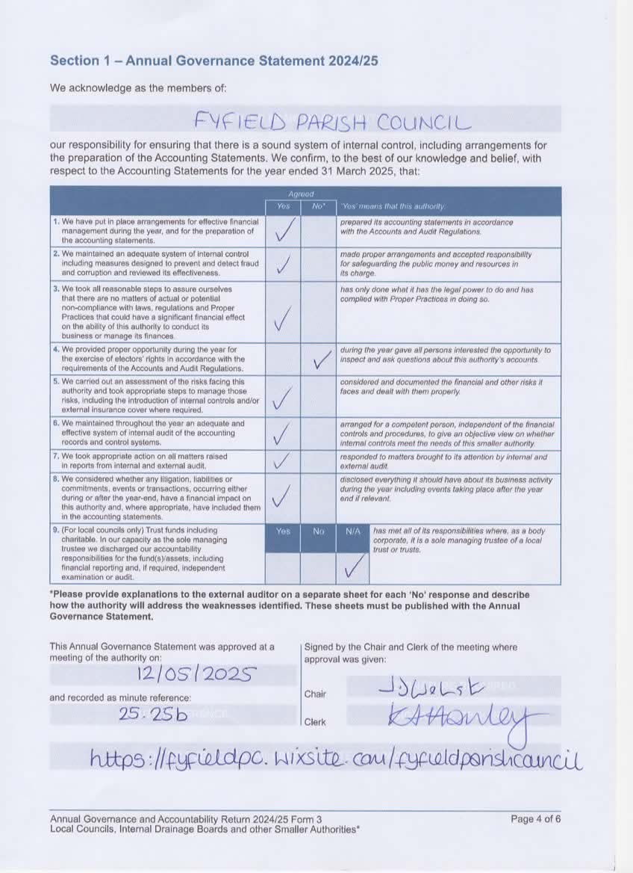

Line 4 - A “No” response was ticked for this section because the exercise of elector’s rights was not provided. This was due to a staff change in late June 2024 and the new clerk was unaware of this requirement. This mistake has been identified and the exercise of public rights will be adhered to for 2024/25 in line with this requirement.